**LAB # 2**

Diagnostic Utilities of Networks

**OBJECTIVE**

To learn about and practice some of the Diagnostic Utilities for use with computer networks.

**THEORY**

Following table gives the descriptions of different diagnostic Utilities.

|  |  |  |  |
| --- | --- | --- | --- |
| |  | | --- | | **Diagnostics** U**tility** | | |  | | --- | | **Functions** | |
| |  | | --- | | IPCONFIG | | |  | | --- | | Verifies a TCP/IP configuration, including DHCP, DNS, and WINS server addresses. | |
| |  | | --- | | FINGER | | |  | | --- | | Retrieves system information from a remote computer that supports the TCP/IP Finger service. | |
| |  | | --- | | NSLOOKUP | | |  | | --- | | Examines entries in the DNS database that pertain to a particular host or domain. | |
| |  | | --- | | HOSTNAME | | |  | | --- | | Returns the local computer’s hostname for authentication. | |
| |  | | --- | | NETSTAT | | |  | | --- | | Displays protocol statistics and the current state of TCP/IP connections. | |
| |  | | --- | | NBTSTAT | | |  | | --- | | Check the state of current NetBIOS over TCP/IP connections, updates the LMHOSTS cache, or determines your registered name &scope ID. | |
| |  | | --- | | Route | | |  | | --- | | Views or modifies the local routing table | |
| |  | | --- | | Tracert | | |  | | --- | | Verifies the route used from the local host to a remote host. | |
| |  | | --- | | Address Resolution | | |  | | --- | | Displays a cache of locally resolved IP addresses to Media Access Protocol (ARP) Control (MAC) addresses. | |

**Table 5.1** Diagnostic tools

**Ping**  **Objective**

Verify connections to a remote computer or computers

**Theory**

The ping command verifies connections to remote computer or computers, by sending ICMP echo packets to the computer and listening for echo reply packets. Ping waits for up to 1 second for each packet sent and prints the number of packets transmitted and received. Each received packet is validated against the transmitted message. By default, four echo packets containing 64 bytes of data (a periodic uppercase sequence of alphabetic characters) are transmitted.

You can use the ping utility to test both the computer name and the IP address of the computer. If the IP address is verified but the computer name is not, you may have a name resolution problem. In this case, be sure that the computer name you are querying is in either the local HOSTS file or in the DNS database. The Ping stands for Packet Internet Groper.

**Parameters**

***-t***

Pings the specified computer until interrupted.

***-a***

Resolve addresses to computer names.

***-n count***

Sends the number of ECHO packets specified by count. The default is 4.

***-l length***

Sends ECHO packets containing the amount of data specified by length. The default is 64 bytes; the maximum is 8192.

***-f***

Sends a Do not Fragment flag in the packet. The packet will not be fragmented by gateways on the route.

***-i ttl***

Sets the Time To Live field to the value specified by TTL.

***-v tos***

Sets the Type Of Service field to the value specified by TOS.

***-r count***

Records the route of the outgoing packet and the returning packet in the Record Route field. A minimum of 1 and a maximum of 9 computers may be specified by count.

***-s count***

Specifies the timestamp for the number of hops specified by count.

***-j computer-list***

Routes packets via the list of computers specified by computer-list. Consecutive computers may be separated by intermediate gateways (loose source routed). The maximum number allowed by IP is 9.

***-k computer-list***

Routes packets via the list of computers specified by computer-list. Consecutive computers may not be separated by intermediate gateways (strict source routed). The maximum number allowed by IP is 9.

***-w timeout***

Specifies a timeout interval in milliseconds.

***destination-list***

Specifies the remote computers to ping.

**Example 5.1**

Y:\>ping sirsyed

Output as follows:

Pinging sirsyed [192.168.1.1] with 32 bytes of data:

Reply from 192.168.1.1: bytes=32 time<10ms TTL=255

Reply from 192.168.1.1: bytes=32 time<10ms TTL=255

Reply from 192.168.1.1: bytes=32 time<10ms TTL=255

Reply from 192.168.1.1: bytes=32 time<10ms TTL=255

**Example 5.2**

Output as follows:

Y:\>ping aurangzeb

Pinging aurangzeb [192.168.1.5] with 32 bytes of data:

Reply from 192.168.1.5: bytes=32 time<10ms TTL=128

Reply from 192.168.1.5: bytes=32 time<10ms TTL=128

Reply from 192.168.1.5: bytes=32 time<10ms TTL=128

Reply from 192.168.1.5: bytes=32 time<10ms TTL=128

**Exercise 5.3**

On command prompt, type

Y:\>ping 192.168.2.145

Record the output:

___________________________________________________________

___________________________________________________________

**Exercise 5.4**

On command prompt, type

Y:\>ping 192.168.1.3

Record the output

___________________________________________________________

___________________________________________________________

**Ipconfig**

**Theory**

This diagnostic command displays all current TCP/IP network configuration values. This command is of particular use on systems running DHCP, allowing users to determine which TCP/IP configuration values have been configured by DHCP.

ipconfig [/all | /renew [adapter] | /release [adapter]]

**Parameters all**

Produces a full display. Without this switch, ipconfig displays only the IP address, subnet mask, and default gateway values for each network card.

**Example 5.5**

Y:\> ipconfig

Output as follows:

Windows NT IP Configuration

Ethernet adapter Elnk31:

IP Address. . . . . . . . . : 192.168.2.13

Subnet Mask . . . . . . . : 255.255.0.0

Default Gateway . . . . : 192.168.1.8

***renew [adapter]***

Renews DHCP configuration parameters. This option is available only on systems running the DHCP Client service. To specify an adapter name, type the adapter name that appears when you use ipconfig without parameters.

***release [adapter]***

Releases the current DHCP configuration. This option disables TCP/IP on the local system and is available only on DHCP clients. To specify an adapter name, type the adapter name that appears when you use ipconfig without parameters.

With no parameters, the ipconfig utility presents all of the current TCP/IP configuration values to the user, including IP address and subnet mask. This utility is especially useful on systems running DHCP, allowing users to determine which values have been configured by DHCP.

**Example 5.6**

Y:\> ipconfig /?

Output as follows:

Windows 8 IP Configuration

Usage: ipconfig [/? | /all | /release [adapter] | /renew [adapter]]

/? Display this help message.

/all Display full configuration information.

/release Release the IP address for the specified adapter.

/renew Renew the IP address for the specified adapter.

The default is to display only the IP address, subnet mask and default gateway for each adapter bound to TCP/IP.

For Release and Renew, if no adapter name is specified, then the IP address leases for all adapters bound to TCP/IP will be released or renewed.

**Exercise 5.7**

On command prompt, type

Y:\> ipconfig /all

Record the output

__________________________________________________________________

__________________________________________________________________

**Exercise 5.8**

In this procedure, you use the Ipconfig utility to view an IP configuration and the PING utility to test your workstation and connections to another TCP/IP host.

**Procedure:**

◻ Use the Ipconfig utility to verify that your TCP/IP configuration has initialized.

At a command prompt, type:

Y:\>Ipconfig

If the configuration is correctly initialized the IP address, subnet mask, and default gateway (if configured values display).

◻ Ping the loopback address to verify that TCP/IP is installed and loaded correctly. At a command prompt, type:

Y:\>ping 127.0.0.1

◻ Ping the IP address of your computer to verify that you added it correctly. Type:

Y:\>ping 172.168.5.1

Ping the IP address of your second computer to verify that you can communicate with a host on the local network. Type:

Y:\>ping 172.168.5.2

◻ If a remote host is available on your configuration, ping the IP address of the remote host to verify that you can communicate through a router. Type:

**Y:\>ping IP address of remote host**

Write the output of each

_____________________________________________________________________

_____________________________________________________________________

**Nslookup**

This diagnostic tool displays information from Domain Name System (DNS) name servers. Before using this tool, you should be familiar with how DNS works. Nslookup is available only if the TCP/IP protocol has been installed.

*nslookup [-option ...] [computer-to-find | - [server]]*

**Modes**

Nslookup has two modes: ***interactive*** and ***non-interactive.***

If you only need to look up a single piece of data, use non-interactive mode. For the first argument, type the name or IP address of the computer to be looked up. For the second argument, type the name or IP address of a DNS name server. If you omit the second argument, the default DNS name server will be used.

If you need to look up more than one piece of data, you can use interactive mode. Type a hyphen (-) for the first argument and the name or IP address of a DNS name server for the second argument. Or, omit both arguments (the default DNS name server will be used).

Nslookup Commands

Nslookup: finger

Connects with the finger server on the current computer. The current computer is defined when a previous lookup for a computer was successful and returned address information (see the set querytype=A command).

***finger [username] [> filename] | [>> filename]***

Nslookup: ls

Lists information for a DNS domain. The default output contains computer names and their IP addresses. (When output is directed to a file, hash marks are printed for every 50 records received from the server.)

***ls [option] dnsdomain [> filename] | [>> filename]***

**NSLOOKUP Syntax**

***Nslookup [-option …] [computer-to-find | - [server]]***

**Object:**

**To use NSLOOKUP in command mode**

◻ At a command prompt, modify the properties so that it has a screen buffer size of 50

Use the Layout property page to do this

◻ If the command prompt is not full-screen, press ALT+ENTER

◻ Type the following command

**Nslookup hostx**

Where hostx is a host in your domain. NSLOOPKP will return the IP address of the computer hostx because the information is stored in the DNS database.

◻ Exit the command prompt

**Hostname: -** It returns the local computer host name.

**Exercise 5.9**

On command prompt, type

Y:\username>hostname

Record the output

**Netstat**

Displays protocol statistics and the current state of TCP/IP connections

**Exercise 5.10**

On command prompt, type

Y:\username>netstat

Record the output

___________________________________________________________

**NBTSTAT**

Check the state of current NetBIOS over TCP/IP connections, updates the LMHOSTS cache, or determines your registered name & scope ID

**Exercise 5.11**

On command prompt, type

Y:\username>nbtstat

**Read the different options of nbtstat command.**

**Exercise 5.12**

On command prompt, type

Y:\username>nbtstat -n

Record the output

**Exercise 5.13**

On command prompt, type

**Y:\username>nbtstat –s**

**Record the output**

__________________________________________________________

__________________________________________________________

**Exercise 5.14**

On command prompt, type

Y:\username>nbtstat –n

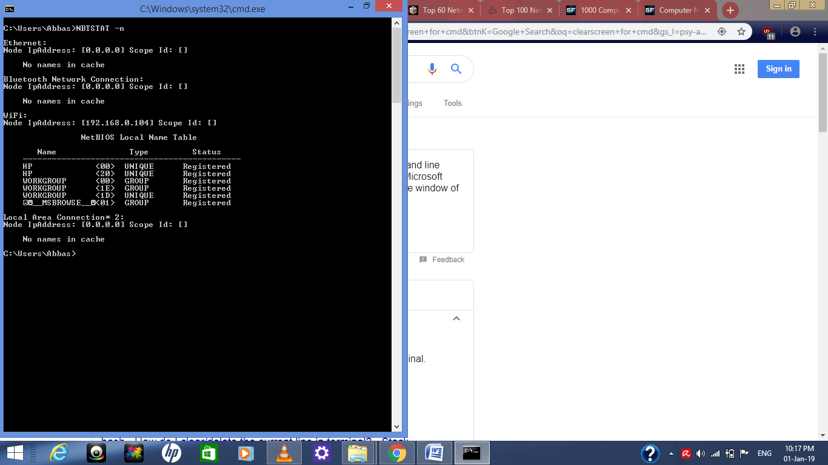The screen looks like this

**Record the output**

**Tracert**

Verifies the route used from the local host to a remote host.

Exercise 4s)

On command prompt, type

Y:\username>tracert –h 56

-h option maximum number of hops for a search to a target.

**Record the output**

___________________________________________________________________

**Exercise 5.15**

On command prompt, type

Y:\username>tracert –h 133

Record the output

___________________________________________________________________

**Address Resolution Protocol (ARP)**

Displays a cache of locally resolved IP addresses to Media Access Control Address.

◻ Ping the local Linux based host. Use the arp to check the MAC Address

What is the output?

**Exercise 5.16**

Ping the non existent local host. Check ARP cache to see the MAC Address.

**Exercise 5.17**

Ping a remote host. Check ARP cache. What MAC Address has been entered into the cache

**Ifconfig -- configure a network interface**

**SYNOPSIS**

ifconfig [interface]

ifconfig interface [aftype] options | address ...

**DESCRIPTION**

Ifconfig is used to configure the kernel-resident network interfaces. It is used at boot time to set up interfaces as necessary. After that, it is usually only needed when debugging or when system tuning is needed. If no arguments are given, ifconfig displays the status of the currently active interfaces. If a single interface argument is given, it displays the status of the given interface only; if a single -a argument is given, it displays the status of all interfaces, even those that are down. Otherwise, it configures an interface down. Otherwise, it configures an interface.

**OPTIONS**

***interface***

The name of the interface. This is usually a driver name followed by a unit number, for example eth0 for the first Ethernet interface up. This flag causes the interface to be activated. It is implicitly specified if an address is assigned to the interface down This flag causes the driver for this interface to be shut down.

***Who -*** It shows who is logged on.

**-m** Same as `who am i'.

***-q, --count***

Print only the login names and the number of users logged on. Overrides all other options.

-***s*** Ignored; for compatibility with other versions of who.

**HOME ASSIGNMENT**

Q1: Which is the basic Networking Utilities Troubleshooting Tool use every IT Pro.?

Q2: How can we assign IP to our system statically using Command Prompt?

Q3: Can we use two IPs of same subnet on a system?

Q4: Difference between Ping and Path Ping command?

Q5: Find all Active/ Used IP addresses on your network

Q6: What TCP /IP settings are used on your system?

Q7: How to verify connection with remote computer?